Function Recursion
Calling the function within same function is called function recursion.
In function recursion calling function and called function both are same.

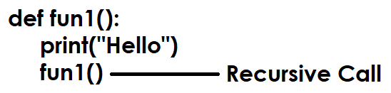

Function recursion is a programming technique where a function calls itself, directly or indirectly, to solve a problem by breaking it down into smaller, simpler instances of the same problem, requiring a base case to stop the self-calls and prevent infinite loops, and effectively solving complex tasks like factorial, tree traversals, or sorting algorithms.

Recursion required 2 statements or steps
- Base case
- Recursive step

Base Case: A crucial condition that, when met, stops the recursion and returns a value, preventing infinite calls.

Recursive Step: The part where the function calls itself with a simpler version of the problem.

If the base case is not define, python runtime repeats function call 1000 time. It is nothing the default base case used by python is 1000.

How to find base case or recursion depth?
>>> import sys
>>> sys.getrecursionlimit()
1000

How to change base case or recursion depth?
>>> import sys
>>> sys.getrecursionlimit()
1000
>>> sys.setrecursionlimit(10)
>>> sys.getrecursionlimit()
10

def fun1():  print("PYTHON")  fun1() # Recursive step  fun1() | Output  PYTHON  PYTHON  PYTHON  PYHTON  1000 times
import sys  sys.setrecursionlimit(10)  def fun1():  print("PYTHON")  fun1() # Recursive step  fun1() | Output  PYTHON  PYTHON  PYTHON  PYTHON  26 times
n=1  def fun1():  global n  if n<=5: # Base case  n=n+1  print("PYTHON")  fun1() # Recursive step  fun1() | PYTHON  PYTHON  PYTHON  PYTHON  PYTHON

In recursion output/result of one function is used as input for another function call.
def factorial(n):  if n==0: # Basecase  return 1  else:  return n*factorial(n-1) # Recursive Case  res=factorial(3)  print(res) | Output  6

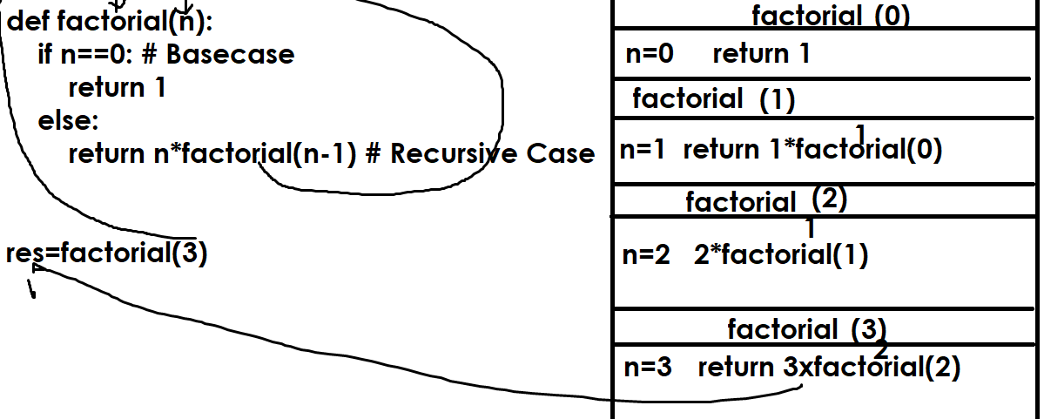

# Write a program to find sum of digits  # using function recursion  def sum_of_digits(num):  if num==0:  return 0  else:  return num%10+sum_of_digits(num//10)  res=sum_of_digits(123)  print(res) | Output  6

Modules and packages

What is module in python?
A module is nothing a python program
A module is a python file with extension .py
A python application or project is a collection of modules or programs.
Modular programming allows dividing the functionality of an application into number programs and each program is called module.

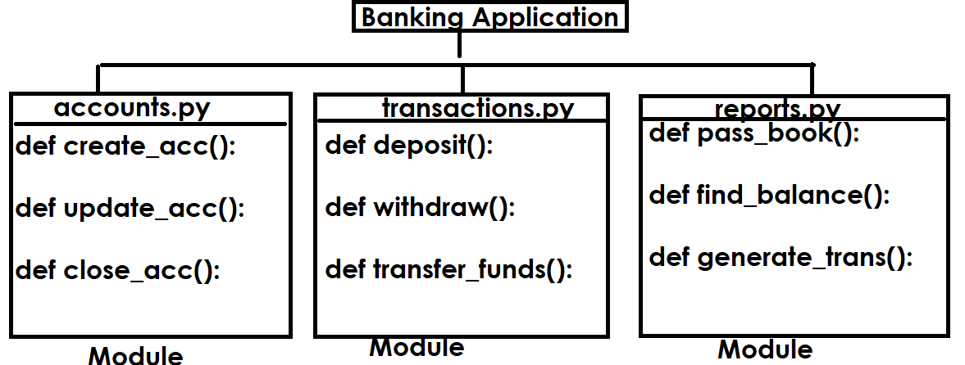
A python program or module is collection variables, functions and classes.
Advantage of modular programming
- Easy to understand
- Reusability
- Modularity

Python modules are 2 types
- Predefined modules
- User defined modules

Predefined modules
The existing modules or programs are called predefined modules. These modules/programs are provided by python or third party vendors

Example: math, sys, os, random, calendar, datetime,…
These inbuilt or predefined modules are also called libraries.

User defined modules
The modules or programs build by programmer are called user defined modules and these application specific modules.

Example: accounts.py, authentication.py, transations.py, reports.py

How to use the content of one module inside another module?

import statement or import keyword

import is a keyword, which is used to include the content of one module inside another module (OR) to use the content of one module inside another module.

Syntax-1: import module-name
Syntax-2: import module-name as alias-name
Syntax-3: from module-name import *
Syntax-4: from module-name import identifier-1,identifier-2
Syntax-5: from module-name import identifier-1 as alias-name

Module1.py | Module2.py
x=100 # Global Variable  def fun1():  print("inside fun1")  def fun2():  print("inside fun2") | import module1  print(module1.x)  module1.fun1()  module1.fun2()  Output  100  inside fun1  inside fun2

